Game Dev Challenges and Programming

Basic Concepts

Assets & Pipelining
The collective entirety of a game’s playable “world” alternatively called gameplay universe by my wiser dictionary, is ultimately made of some basic 3D or 2D “things”,”stuff” and objects and a set of rules that define how they are to behave in the gameworld.

Assets

Mesh
An actual “physical” object in the world.

Textures
Are 2D images used for different purposes. There are different variations of textures defining an equally necessary aspect of for it’s mapping.

Albedo Map / Diffuse Map
Is the image itself.

Normal Map
Stores surface direction xyz in RGB.
Used for fake lighting detail

Mask Map / Control Map / Alpha Mask/ Opacity Mask / Roughness Mask / Gloss Mask / Specular Mask
Controls where and how effects apply.

Materials
These are shader setups defining how to take textures and simulate. They are instructions for rendering data and are mainly concerned about how to render things on “surfaces”.

Material Instances
Tweaked version of material still reliant on the base version. e.g: We have a Sky material then we create a morning on outta it

Shader Node Graphs
Are abstracted inputs to shader compilation.

Pipelining

Cell
Game worlds are purposefully divided into chunks for manageability upon load. These chunks are called Levels/Cells/Worlds in Game Engine system view.
From open world games to linear ones they all use this system but in open world ones typically the world loading should happen by more estimations and according to variables such as draw distance and player location to keep the open world from being loaded late.

Level/UMap
A saved definition of a noticeably large world section.

UWorld
A runtime simulation instance created from one or more umap defined levels.
The engine could run/bind to only one UWorld at a time.

Graphics

Lights

Global Illumination

Light Maps (old solution)

RTGI (new solution)

Reflections
Generally there are 2 main reflection models:
- Blinn Phong
- Physically Based Rendering/Microfacet BRDF
- In the Blinn Phong model:
Final Color = Diffuse + Specular Highlight
- In the modern PBR instead we have:
Base Color,Metallic, Roughness

Texture Cubes (Blinn Phong)
Used static textures as reflections.

Screen Space Reflections
Dynamic reflections cast.

Stencil

Culling

Technical Art Concepts

Sky
Previously implemented as a dome mesh with materials defining what was rendered on it but new procedural methods have emerged in UE5 for per pixel rendering such as the atmosphere role.

Adhoc

Rendering

Optimization Aliasing Reduction
Aliasing happens as the details get too small for the pixels to be rendered well enough. The reason in many older games this wasn’t as big of a deal was with how the engines handled 3D objects through decreasing the LOD / Using a decreased LOD version of objects after a distance back in the days of DL1 and such.

3D Modelling

Optimization Technique
Typically the 3D models use rather simple meshes for hair and then proceed to implement the hair thru textures transparency to give the illusion of empty pots in hair.

UDK (Older Approaches)
Upon running UDK it loads the core modules and Engine packages (some basic default template) upk files which are precompiled asset libraries mounted at runtime.
In UDK sky is a dome, like an actual 3D mesh as a dome

Material Editor
The material editor actually builds the GPU shader graph for materials.
It uses a chain of nodes to achieve it’s results. This chains of nodes is made of:
- Nodes:basic building blcoks of material graphs.
Within the material editor we use ctrl + click to drag the nodes close and away to each other.
In order to connect nodes to one another we click on their pins. In order to cut connection among nodes we use Alt + Click

Nodes
Each node could be from:
- The material function library:
- Material Expression:
Either way the input pins of a node are on the right side, with the output pins on the left side.

Material Output Nodes
These are the final interface between graph and the GPU shader result. Everything built in graph must ultimately be plugged into them. It defines the values the generated shader must compute.
- Every material must have ONE single output node.
- The output node is always there by default with a pretty descriptive name like Material or PreviewMaterial_2.
- The output node does not have an output pin cause… it IS the output pin itself.
The output node has the following input pins:
- Diffuse: Takes color.
- DiffusePower:
- Emissive:
- Specular: Strength of light reflection effect.
- SpecularPower: The amount of area of reflection dividee.
- Opacity:
- OpacityMask:
- Distortion:
- TransmissionMask:
- TransmissionColor:
- Normal:
- CustomLighting:
- CustomLightingDiffuse:
- AnisotropicDirection:
- WorldPositionOffset:

Material Expressions
They are all the non output nodes that we add.

Constant3Vector
It represents a color.

Unreal Engine 5.7

Documentation
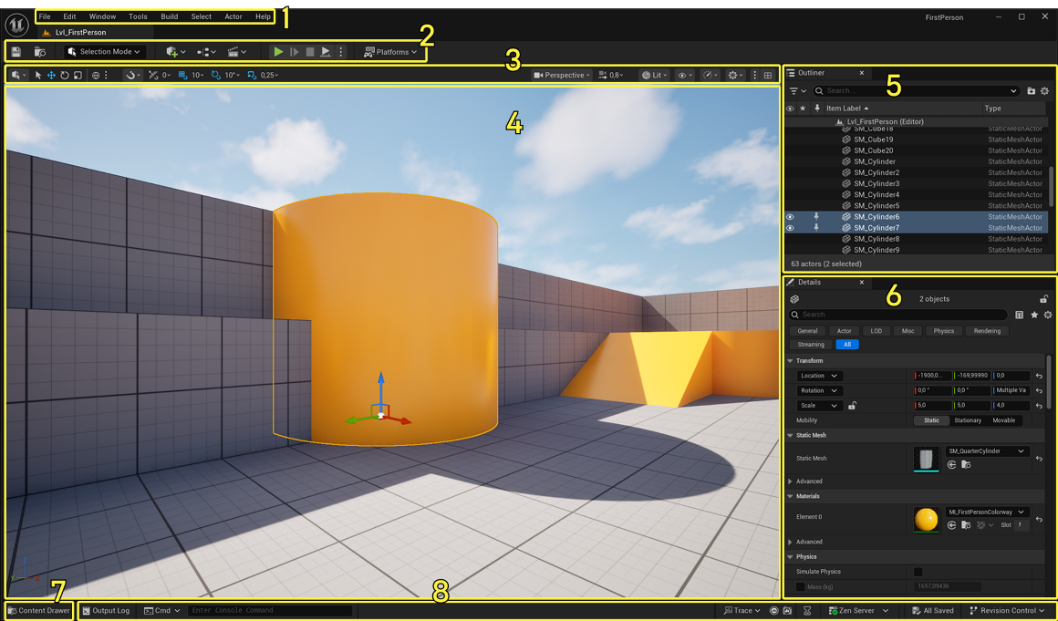
1 | Menu Bar | Uses these menus to access common application actions, like saving, and creating new levels. You’ll also find options for opening editor windows and tools that are useful for specific functions like debugging and more.
2 | Main Toolbar | Contains shortcuts for some of the most common tools and editors in Unreal Engine, as well as shortcuts to enter Play mode (run your game inside Unreal Editor) and to deploy your project to other platforms.
3 | Viewport Toolbar | Includes common tools used to manipulate objects in the level by moving, rotating, and scaling them, as well as snapping tools for moving objects along a grid, rotation angle, or scaling amount. It also includes perspective and orthographic views along with debugging and visualization view mode and other settings you can use while working in the viewport.
4 | Level Viewport | Displays the contents of your Level, such as Cameras, Actors, Static Meshes, and so on.
5 | Outliner | Displays a hierarchical tree view of all content in your Level.
6 | Details panel | Appears when you select an Actor. Displays various properties for that Actor, such as its Transform (position in the Level), Static Mesh, Material, and physics settings. This panel displays different settings depending on what you select in the Level Viewport.
7 | Content Drawer | Opens the Content Drawer, a temporary Content Browser window, from which you can access all of the Assets in your Project.
8 | Bottom Toolbar | Contains shortcuts to the Command Console, Output Log, and Derived Data functionality. Also displays source control status.

The Main Toolbar contains shortcuts to some of the most used tools and commands in Unreal Editor. It is divided into the following areas:
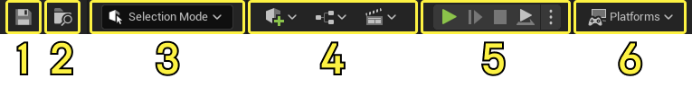
Number | Name | Description
1 | Save button | Click this button to save the level that is currently open.
2 | Select the open level | Click this button to show the currently loaded level in the Content Browser. This will open the most recently used Content Browser, which can be the docked Content Drawer or standalone Content Browser panel.
3 | Mode selection | Contains shortcuts for quickly switching between different modes to edit content within your level. These modes also change the primary behavior of the Level Editor, which can include toolbar options designed for each mode specifically. You can click the links to go to their respective pages to learn more about a mode.  - Selection  - Landscape  - Foliage  - Mesh Paint  - Modeling  - Fracture  - Brush  - Animation
4 | Content shortcuts | Contains shortcuts for adding and opening common types of content within the Level Editor.  - The Create button can be used to choose from a list of common Actor Types and Recently Used assets from the Content Browser to quickly add to your level.  - The Blueprints button can be used to create and access blueprints.  - The Cinematics button can be used to create and access a Level Sequence or Master Sequence cinematic.
5 | Play mode controls | Contains the shortcut buttons Play, Skip, Stop, and Eject for running your game in the editor.
6 | Platforms menu | Contains a series of options you can use to configure, prepare, and deploy your project to different platforms, such as desktop platforms such as Windows, macOS and Linux, mobile, and consoles.  Some platforms, such as mobile and console, require additional setup and configuration of your project. These can include their own software development kit (SDK) installations or non-disclosure agreements (NDAs) to access them.

Viewport Toolbar
The Viewport Toolbar can be used to accomplish a number of tasks when building levels. It is located at the top of the Level Viewport, and its settings and tools are grouped into the following categories:
Number | Name | Description
1 | Transform and Snapping tools | These are the options to swap between different Transform tools and change the snapping options.
2 | Camera tools | These are the options to switch between Perspective and Orthographic views and change camera movement speed.
3 | View Mode and Show Flag options | These are the options to pick between different view modes like Lit, Unlit, and Wireframe, and show flags related to the current viewport to hide and reveal types of content in the Level Viewport.
4 | Performance and Scalability tools | This dropdown can be used to reveal settings like Viewport Scalability and Material Quality Level.
5 | Viewport options | These options can be used to change viewport related settings, like mouse sensitivity in the Level Viewport.
To learn more about this toolbar, read the Viewport Toolbar documentation.

Personal Understanding

Game World Sections

Cell
Game worlds are purposefully divided into chunks for manageability upon load. These chunks are called Levels/Cells/Worlds in Game Engine system view.
From open world games to linear ones they all use this system but in open world ones typically the world loading should happen by more estimations and according to variables such as draw distance and player location to keep the open world from being loaded late.

Level/UMap
A saved definition of a world section.

UWorld
A runtime simulation instance created from one or more umap defined levels.

Outliner
It represents and loads the engines engine specific filesystem accordingly.

Material Editor
Serves the same purpose as in UDK with some minor differences in UI.

Nodes
Each node could be from:
- The material function library:
- Material Expression:
Either way the input pins of a node are on the Left side, with the output pins on the Right side.

Material Output Nodes
These are the final interface between graph and the GPU shader result. Everything built in graph must ultimately be plugged into them. It defines the values the generated shader must compute.
- Every material must have ONE single output node.
- The output node is always there by default with a pretty descriptive name like Material or PreviewMaterial_2.
- The output node does not have an output pin cause… it IS the output pin itself.
It is worth mentioning that

- Base Color: Takes color.
- DiffusePower:
- Emissive:
- roughness:
- Opacity:
- OpacityMask:
- Distortion:
- TransmissionMask:
- TransmissionColor:
- Normal:
- CustomLighting:
- CustomLightingDiffuse:
- AnisotropicDirection:
- WorldPositionOffset:

